DBMS ASSINGMENT

Tathagat Banerjee

17BCE7100

**1. Find the names of the owners who are joint or sole owners of at least one of the flats**

**where they reside.**

select distinct ow.Owner_name

from database1.resides as r JOIN database1.owns as o JOIN database1.owner as ow

where r.Owner_id = o.Owner_id

and

r.Flat_no = o.Flat_no

and

r.Owner_id = ow .Owner_id

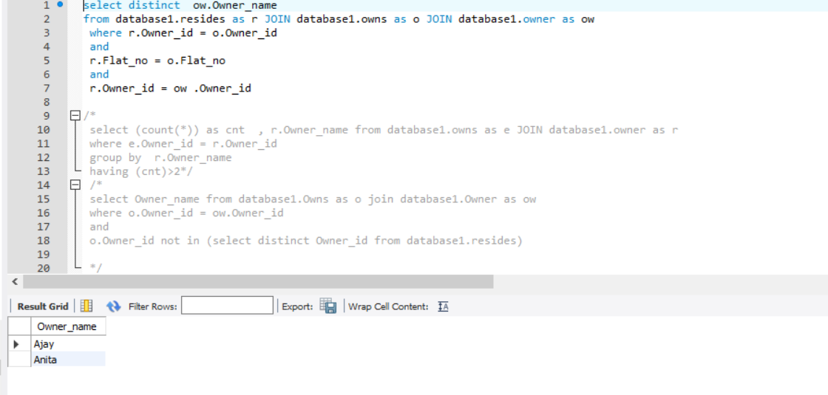

**2. Find the names of the owners who own most of the flats.**

select r.Owner_name , (count(*)) maximum from database1.owns as e JOIN database1.owner as r

where e.Owner_id = r.Owner_id

group by r.Owner_name

ORDER BY maximum DESC

LIMIT 1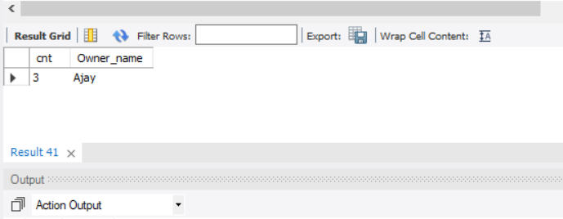

**3. Find the names of the owners who do not reside anywhere.**

select Owner_name from database1.Owns as o join database1.Owner as ow

where o.Owner_id = ow.Owner_id

and

o.Owner_id not in (select distinct Owner_id from database1.resides)

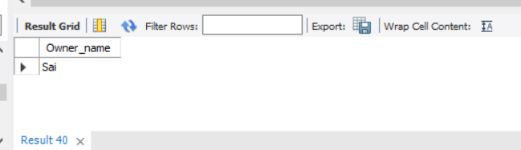

**4. Find the names of all owners who reside in a flat whose age is same as that of the age of**

**the owner.**

select distinct o.Owner_name from database1.Owner as o JOIN database1.resides as r JOIN database1.owns as ows JOIN database1.Owner as o1

where

o.Owner_id = r.Owner_id

and

r.Flat_no = ows.Flat_no

and

r.Owner_id = o1.Owner_id

and

o.Owner_age = o1.Owner_age

